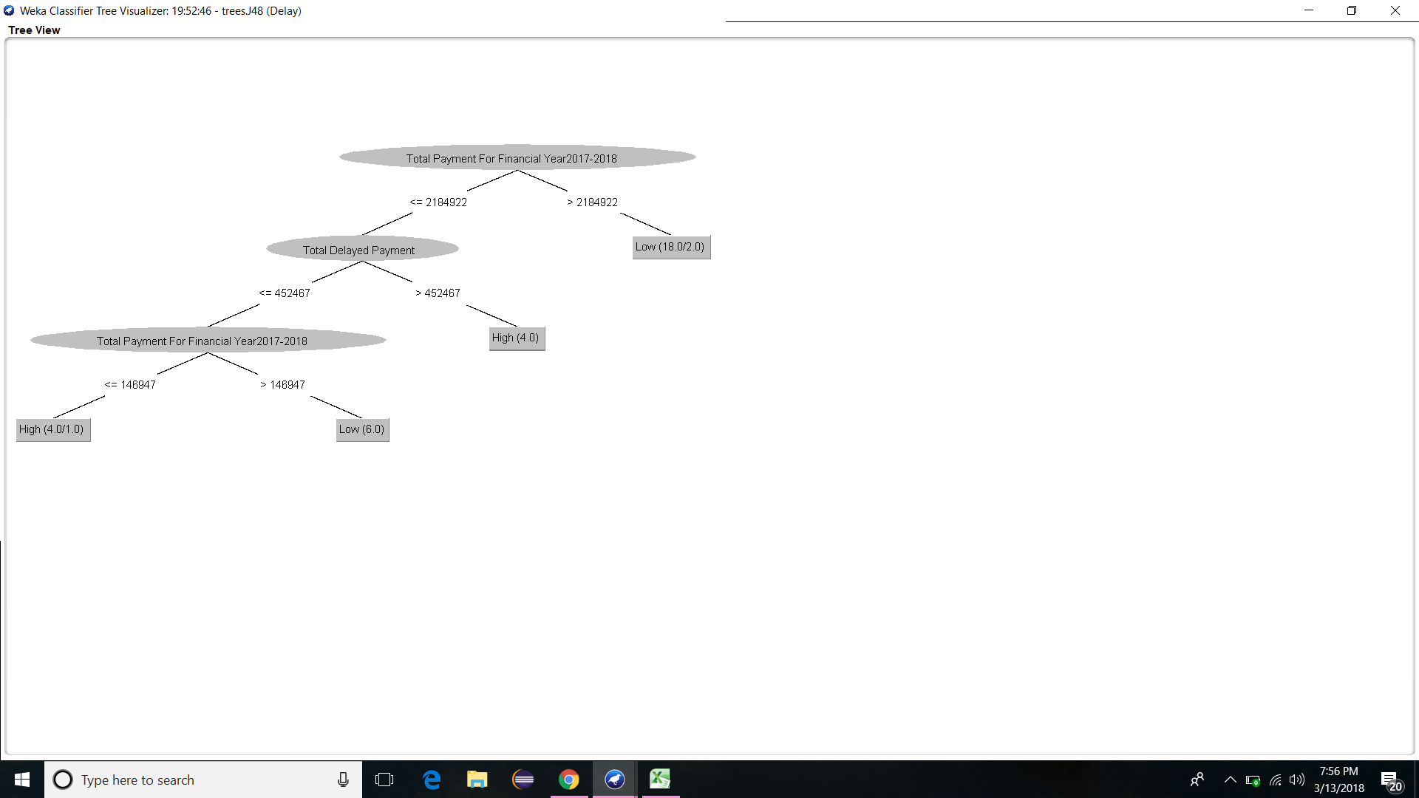

Fig 4.2 classification tree of delay payments

The first data set that we are mining is to find the basis of classification of states into low and high delay states on the basis of Total delayed payment (The amount that has been delayed and have to be payed) and Total payment

( The wages to be given/have been given to the workers).

After classification of data using J48 algorithm the above figure is the generated tree. It is easily understood from the figure that if the total payment of the state is greater than Rs21,84,922 then the state is more likely to have low delayed payment perentage. The next observation is that if the total payment of the state is less than the above amount and total delayed payment is greater than Rs4,52,467 then the state is likely to have high delay.

By using the above classification tree we can try to anticipate the delay in the state by looking at the above details.